Analysis of Turnover at Float Glass Mirror Image, Inc.

BAN 554: Capstone Project

Dr. Jessica Magnus

April 27th, 2025

Cara Arena, Deanna Ingle, Mateo Lawton

**Analysis of Turnover at Float Glass Mirror Image, Inc.**

Employee turnover at Float Glass Mirror Image, Inc. (FGMI) has reached alarming levels, with the company experiencing an annual separation rate of 18%. This rate is drastically higher than both the national manufacturing average of 2.7% and Michigan’s manufacturing sector average of 3.4%. An in-depth analysis of FGMI’s internal workforce data, operational metrics, and employee engagement survey results reveal critical factors driving turnover and underscores the consequences of turnover on FGMI’s stability, performance, and bottom-line.

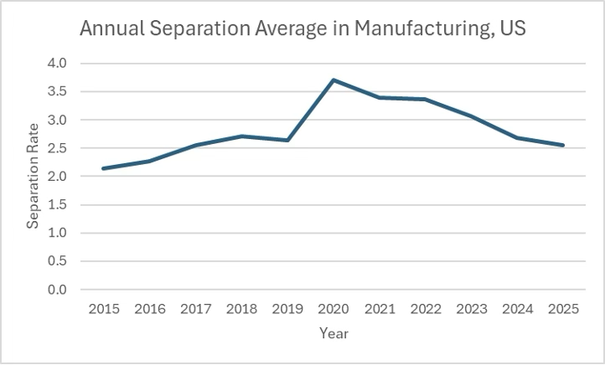

The financial impact of turnover at FGMI is substantial. Based on estimates from the Work Institute (2023) and SHRM (2022), the average cost to replace an employee in manufacturing ranges between $5,000 and $25,000, or approximately 33% of their annual salary. Given that FGMI lost 55 employees in a single year, the resulting direct replacement costs range from $275,000 to $1.375 million. These figures exclude indirect impacts such as lost productivity, increased error rates, diminished product quality, and customer dissatisfaction. This financial burden is compounded by the operational consequences identified in the company’s delivery performance. Over five years, a moderate positive correlation (r = 0.56) was observed between employee separations and delivery-related issues, with a sharp spike in errors accompanying the rise in separations in Year 5. Additional forecasting done by our team shows that delivery issues leading to poor customer service will increase to a total of 362 by year ten if FGMI does not institute a change. These findings clearly demonstrate that high turnover directly disrupts FGMI’s ability to maintain operational consistency and customer service standards.

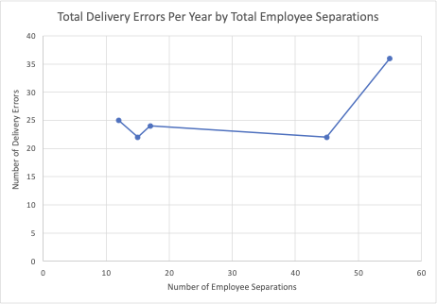

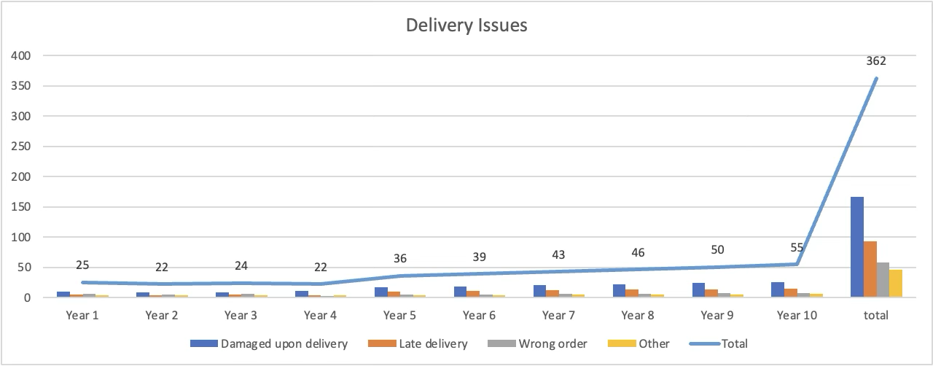

A deeper examination of the Staff Population and Hours Worked data highlights significant staffing and workload issues. Across the five-year period, workload increased by 25%, yet staffing levels remained stagnant. During Year 5, turnover rates by department were particularly concerning. Administration, Glass Manufacturing, and Line Maintenance all experienced turnover rates exceeding 15%, indicating widespread instability. Compounding this issue, FGMI’s overtime burden was extremely high: 94,500 overtime hours were recorded against 122,400 regular hours worked, meaning overtime represented approximately 77% of regular work hours. Departments such as Glass Manufacturing and Plant Engineering exhibited overtime rates as high as 200 hours per employee per year, drastically increasing the risk of employee burnout.

The overtime dataset at FGMI reveals a dramatic escalation in overtime hours across all departments, particularly when examining the projected figures for Years 6 through 10. From Years 1 to 5, overtime demands steadily increased from 5,210 hours to 47,250 hours annually. However, the forecasts predict an exponential surge: overtime hours are expected to jump from 123,503 hours in Year 6 to an overwhelming 5.76 million hours by Year 9 and reach nearly 9.4 million cumulative hours by Year 10. This forecast trajectory indicates that overtime hours are projected to grow at a far greater rate than staffing levels, workload management, or employee capacity.

Departmentally, Glass Manufacturing and Windshield Fabrication are set to bear the greatest overtime burden, with cumulative projections of 2.58 million and 3.5 million overtime hours, respectively, by Year 10. These two departments alone account for over 65% of all overtime projected across the company. Line Maintenance, Distribution Logistics, and Administration also show steep increases, suggesting that every operational area will experience significant pressure. In the early years, overtime growth was already outpacing staffing adjustments, but the forecasted years reflect a catastrophic imbalance if corrective actions are not taken.

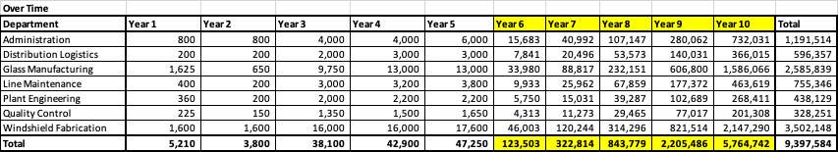

The employee engagement survey reinforces these operational concerns. 94% of employees expressed dissatisfaction with their work-life balance, and 43% cited excessive workloads as a major reason for dissatisfaction. Additionally, 8% specifically mentioned too much mandatory overtime. These findings align with the overtime and staffing data, validating that overextension is a primary driver of employee dissatisfaction and turnover. Employees also reported a lack of managerial support (10%), insufficient opportunities for taking leave (9%), and the burden of constantly training new hires (11%) as contributing factors. These qualitative insights directly mirror quantitative workforce trends, emphasizing the interconnectedness of high workload, poor work-life balance, and inadequate organizational support in driving turnover.

The PTO (Paid Time Off) data at FGMI reveals a sharp and dangerous decline in PTO usage across all departments, compounding the organization's existing risks from flat staffing and runaway overtime. In Years 1 through 3, employees consistently used around 40 hours of PTO annually; however, by Year 5, PTO usage had already dropped by 25–50%, and the forecasted data for Years 6 through 9 shows even steeper declines, with most departments falling to as low as 11 to 14 PTO hours per employee per year. Glass Manufacturing and Windshield Fabrication, two of the departments bearing the heaviest overtime loads, are projected to have PTO usage as low as 9 hours by Year 9—an alarming indicator of systemic overwork and a broken time-off culture.

This trend is extremely detrimental to employee well-being and directly feeds into FGMI’s high turnover rates. PTO is a critical pressure-release valve for stress and burnout; without it, employee exhaustion accelerates rapidly, leading to higher rates of absenteeism, safety incidents, disengagement, and resignation. Internal survey results already show that 94% of employees report poor work-life balance, and declining PTO usage validates that employees are either unable or unwilling to take time off due to workload pressures or cultural barriers. Worse, when employees are unable to recharge, their ability to effectively onboard and train new hires deteriorates, compounding the organization's already critical training bottlenecks and reinforcing the turnover cycle.

In summary, the collapse of PTO usage at FGMI is not simply a symptom of high workload — it is a direct accelerant of workforce burnout and organizational instability. Without immediate action to normalize PTO use, expand staffing, and reinforce a supportive time-off culture, FGMI will continue to see escalating turnover, reduced productivity, rising safety risks, and increasing failure to retain new hires. The data is clear: a workforce that cannot rest is a workforce that cannot sustain.

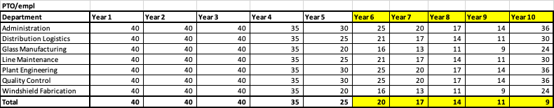

Another significant contributor is compensation. FGMI’s salaries are notably below the averages for comparable manufacturing roles in Lansing, Michigan. Although only 5% of survey respondents explicitly cited pay as a primary concern, salary remains a critical factor in recruitment and retention. In a labor market increasingly driven by competition for skilled tradespeople, sub-market wages will inevitably intensify turnover pressures, particularly among high-performing employees.

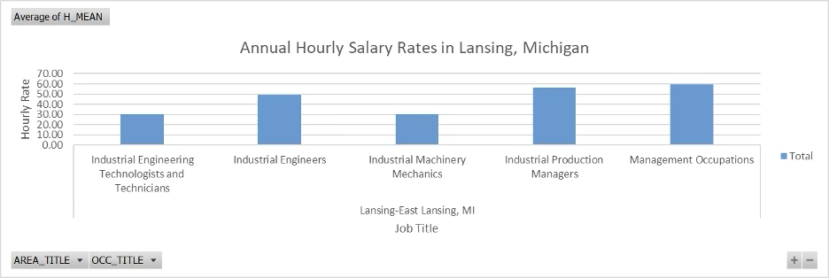

The broader organizational culture appears to be suffering as a result of these operational and compensation shortcomings. An overwhelming 90% of survey respondents reported not feeling valued by the company. This finding underscores a pervasive employee disengagement and dissatisfaction that, if left unaddressed, will continue to drive turnover regardless of operational improvements. Emotional commitment to an organization has long been linked to retention, productivity, and discretionary effort; FGMI’s current climate severely threatens all three.

The cumulative impact of these findings cannot be overstated. Turnover not only drains financial resources but also directly contributes to increased safety risks, lower productivity, and deteriorating quality. Burnout caused by excessive overtime compromises employees' attention and decision-making capabilities, elevating the likelihood of workplace accidents. Likewise, new and inexperienced hires—resulting from frequent separations—require extensive onboarding and training, further stressing existing employees and perpetuating the cycle of disengagement and turnover.

Given these realities, our team’s hypothesis is that increasing staffing at FGMI would improve employee satisfaction and engagement—and thus reduce turnover. Additional staffing would enable a meaningful reduction in mandatory overtime, provide greater flexibility for employees to take time off, and ease the burden of training new hires. Furthermore, with better staffing levels, the company could implement more effective onboarding programs, improve work-life balance, and rebuild trust between management and employees.

Strategic investments in competitive compensation packages are equally critical. Paying at or above local market rates would improve recruitment pipelines, reduce poaching by competitors, and enhance overall retention. Strengthening managerial support structures through leadership training and more frequent one-on-one employee check-ins would also reinforce employee satisfaction, helping to rebuild a sense of value and engagement.

Moving forward, FGMI must closely monitor key workforce metrics to measure the effectiveness of its retention strategies. These metrics should include PTO balances at termination, overtime usage patterns, absenteeism rates, voluntary versus involuntary turnover, and turnover by tenure bands. Analyzing these indicators alongside engagement survey results will provide timely insights into whether initiatives to address workload, compensation, and management support are having the desired impact.

Ultimately, FGMI’s turnover crisis is the result of systemic operational, cultural, and compensation challenges. High turnover is eroding financial performance, operational reliability, safety, and morale. However, by acting decisively on the insights provided by workforce and operational data—particularly by increasing staffing, strengthening leadership support, and restoring work-life balance—FGMI can reverse these trends and create a more resilient, engaged, and productive workforce. Addressing these critical areas is essential for stabilizing the organization and securing its future growth and success.

Our team studied the key drivers of turnover to better understand the impacts within the organization. The most compelling and critical cause of turnover is the unsustainable workload and lack of work-life balance, exacerbated by managerial gaps, limited time off, and the strain ofcontinual onboarding. These factors suggest the organization is in a reactive state, addressing turnover with short-term fixes that further stress remaining staff. Addressing these top issues directly will be essential for improving retention and employee satisfaction. 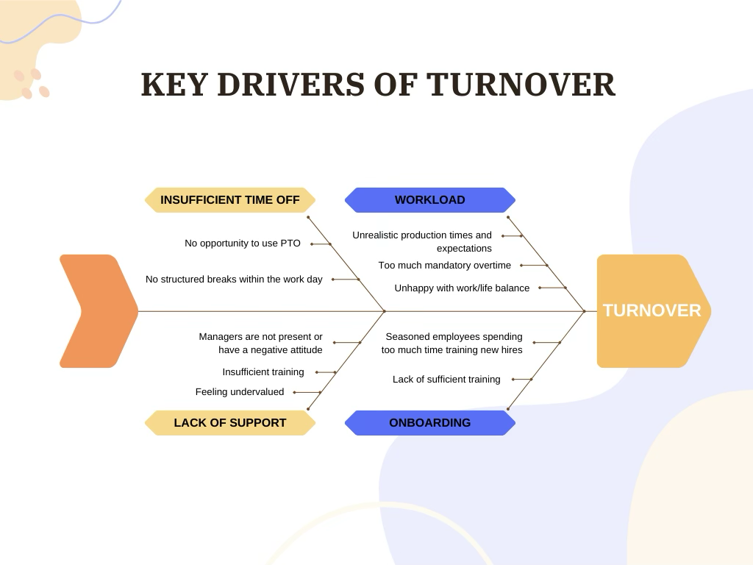

The dependent variable, turnover, was studied in conjunction with the independent variables including PTO, Workload/Overtime, Staffing and Onboarding, and Managerial Support.

**1. PTO (Paid Time Off):** PTO refers to the time employees are allowed to be away from work and still receive pay. This includes vacation, sick days, and personal leave.

* PTO is being examined to determine whether the amount and flexibility of time off affects employee retention.
* Insufficient or inflexible PTO policies may contribute to burnout and dissatisfaction, increasing turnover.
  + Data:
* Correlating PTO usage or availability with turnover rates.
* Employee reports regarding perceived adequacy of PTO.
* Comparing departments with different PTO patterns.

**2. Workload/Overtime:** This variable includes the volume of work assigned to employees, expected production benchmarks, and the number of hours worked beyond the standard shift (e.g., regular overtime demands).

* Used to evaluate whether high workloads or mandatory overtime are leading to employee stress and eventual resignation.
* Higher workloads and frequent overtime contribute to fatigue, dissatisfaction, and ultimately higher turnover.
  + Data:
* Number of overtime hours per department/employee per year
* Employee reports regarding workload stress
* Turnover rates in high-overtime versus low-overtime departments

**3. Onboarding/Staffing/Training Protocols:** This refers to the procedures and quality of introducing new hires to their roles, ensuring proper staffing levels, and providing training to support performance.

* Assesses whether new employees are being adequately prepared and supported, and whether understaffing contributes to turnover.
* Poor onboarding, inadequate staffing, or insufficient training may leave employees feeling unprepared and unsupported, increasing the likelihood of early departure.
  + Data:
* Employee feedback on onboarding and training
* Staff-to-workload ratios

**4. Managerial Support:** Managerial support refers to the extent to which supervisors or managers provide guidance, feedback, encouragement, resources, and fair treatment to their team members. It includes aspects like communication, responsiveness, conflict resolution, and emotional support.

* Evaluates how employees’ relationships with their supervisors impact their decision to stay with or leave the company.
* Low perceived managerial support contributes to disengagement, dissatisfaction, and higher turnover rates.
* Managerial support might be assessed through:
* Employee engagement or satisfaction surveys (e.g., “My manager supports my professional development” or “I feel comfortable going to my manager with concerns”).
* Exit interview data indicating reasons for departure.
* Comparing turnover rates across departments with different leadership styles or satisfaction ratings.
* Frequency of one-on-one check-ins, coaching, or feedback sessions.

**Hypothesis:** If staffing is increased, employee satisfaction and engagement will increase, therefore reducing turnover.

**Impacts of increased staffing:**

* Decreased mandatory overtime hours
* Increased ability to use PTO and take leave
* Reduced workload
* Decreased burnout
* Improved reports of satisfactory work/life balance
* More staff available to train new hires
* Decreased frequency of training new hires per person

Based on the 2024 Training Industry Report and salary data, we calculated the estimated financial utility of training employees and improving staffing. With 75 employees trained, an expected benefit duration of 5 years, and an effect size of 0.23, the total estimated training utility amounts to $1,942,950.00. Ultimately, it is recommended FGMI increase staffing by 25% to reduce turnover rates and improve upon our staffing initiative.

, Picture

Assumptions:

* 75 employees to train as the sales increased by 25% so 75 employees is 25% of the current workforce.
* 5-year duration as we forecast, another 5 years to year 10.
* .23 (23% - dt)
* $23,200 average salaries of each resource

Here are the **median salaries** for each role along with their sources:

* **Administration**: ~$47,460 per year (BLS)
* **Distribution Logistics**: ~$80,880 per year (BLS)
* **Glass Manufacturing**: ~$55,440 per year (BLS)
* **Line Maintenance**: ~$71,953 per year (Salary.com)
* **Plant Engineering**: ~$90,289 per year (PayScale)
* **Quality Control**: ~$47,460 per year (BLS)
* **Windshield Fabrication**: ~$50,680 per year (BLS)

**Reducing Employee Turnover Through Strategic Staffing in Manufacturing**

Employee turnover presents a significant challenge in the manufacturing sector and at Float Glass Mirror Image, Inc. (FGMI), particularly. Turnover has far-reaching impacts within our organization, leading to increased operational costs, loss of institutional knowledge, decreased productivity, and outright disruptions in production and service delivery processes. This analysis explores the hypothesis that enhancing staffing levels can lead to increased employee satisfaction and engagement, thereby reducing turnover. Key factors examined by our team include Paid Time Off (PTO), workload and overtime, and onboarding/staffing practices.

**Impact of Staffing on Workload and Overtime**

High workloads and excessive overtime are primary contributors to employee burnout and turnover in manufacturing settings. A study by Wang et al. (2017) found that occupational stress significantly correlates with burnout among manufacturing workers, adversely affecting their well-being. Moreover, prolonged working hours have been linked to increased safety risks and decreased productivity (Pro Choice Safety Gear, 2023). Increased staffing levels can distribute workloads more evenly, reduce mandatory overtime, and alleviate burnout, contributing to improved employee retention.

**Enhancing PTO Utilization**

The opportunity to utilize hard-earned PTO is critical for employee well-being. Research in the field reveals that a lack of time off leads to psychological strain, negatively impacting job satisfaction and increasing turnover intentions (Binnewies, et al., 2010; Sonnentag, 2012). Furthermore, the inability to take necessary time off can result in decreased productivity and increased health risks within the organization (Lovell, 2004). By increasing staffing, FGMI can ensure adequate coverage, allowing employees to take necessary time off without impacting operations, thereby promoting a healthier work-life balance.

**Optimizing Onboarding and Training**

Effective onboarding is crucial for employee engagement and retention. A study by Smith (2023) emphasized that comprehensive onboarding processes enhance organizational identification and trust, leading to higher job satisfaction and reduced turnover intentions. Additionally, companies that invest in structured onboarding programs report significant improvements in new hire retention and productivity (Augmentir, 2023). Adequate staffing ensures that experienced employees are available to mentor new hires rather than being solely responsible for their training, facilitating smoother integration and reducing the frequency and burden of training responsibilities on individual staff members. Effective onboarding processes have been shown to significantly increase employee engagement, which in turn reduces turnover intentions (Jeske & Olson, 2022).

**Safety Impacts and Productivity Concerns**

Burnout and lack of employee engagement have direct implications for workplace safety and productivity in manufacturing settings. Burnout is associated with decreased attention, impaired decision-making, and reduced adherence to safety protocols, leading to increased workplace accidents and errors (Pro Choice Safety Gear, 2023). Furthermore, burnout contributes to higher rates of absenteeism and presenteeism, resulting in significant productivity losses (Frontiers in Public Health, 2022).

To strengthen the analysis of turnover at FGMI, additional individual employee data is necessary, particularly focusing on overtime hours, leave usage, training experiences, and manager attitudes. In the area of Paid Time Off (PTO), several metrics would offer deeper insights: tracking PTO balance at the time of termination could reveal whether unused PTO signals burnout or a lack of a time-off culture; monitoring the frequency of PTO requests versus approvals would identify whether employees face barriers to taking leave; surveying employees about their awareness of and satisfaction with PTO policies would capture cultural gaps; comparing average tenure to PTO usage patterns could show whether longer-serving employees are more or less likely to take time off; and analyzing absenteeism rates could serve as a proxy for hidden burnout. Financially, understanding the cost of overtime, particularly what FGMI is paying in overtime premiums, would further illuminate the burden on both employees and budgets.

Several analyses would enhance these findings. Correlation analysis between PTO usage and turnover rates could determine if lower PTO use predicts higher attrition. Cohort analysis could compare turnover between employees with high versus low PTO usage, while forecasting models could evaluate whether early signs of limited PTO use predict future departures. Additionally, exit interview data focused on themes like burnout, inability to take time off, or time-off denial would provide qualitative validation.

Regarding workload, absenteeism or sick leave rates could again serve as key proxies for overwork, while direct survey data capturing self-reported workload stress would strengthen internal visibility. Assessing work-to-staff ratios—essentially measuring output expectations per person—would provide a critical operational perspective. To support these metrics, regression analysis could determine whether increased overtime statistically predicts higher turnover. Departmental comparisons of workload and retention could reveal localized problem areas, while sentiment analysis of exit interviews and pulse surveys mentioning overtime and workload stress would enrich qualitative understanding. Finally, control charts monitoring spikes in overtime before turnover waves would help establish predictive patterns.

For managerial support, several additional data points would be vital. Gathering manager effectiveness scores through 360-degree reviews and pulse surveys would gauge leadership quality, while tracking the frequency of one-on-one check-ins could assess relationship-building efforts. Manager span of control—specifically, how many direct reports each manager oversees—would identify potential overload. Tracking promotion and recognition frequency could reveal how well management supports career development, while grievance or conflict resolution rates could surface problems with leadership responsiveness. Finally, comparing turnover rates across managers or departments would highlight where leadership weaknesses most impact retention.

In terms of onboarding and training, measuring the time to full productivity for new hires would assess the effectiveness of initial support systems. Tracking turnover within the first 90 days would reveal how well new employees are integrated. Recruitment data regarding applicant pools and salary competitiveness would show whether hiring challenges stem from external market pressures. Raising salary ranges could be necessary to improve applicant quality and reduce early exits. Additionally, tracking training hours per employee—both given and received—would quantify investment in skill-building and mentorship, helping to stabilize workforce performance.

Finally, several additional metrics would round out a comprehensive turnover analysis. Tracking voluntary versus involuntary turnover rates would distinguish between employees choosing to leave and those being separated for other reasons. Analyzing turnover by tenure band (0–3 months, 3–12 months, and 1+ year) would identify vulnerable points in the employee lifecycle. Understanding the cost of turnover per role would sharpen financial projections; while tracking the time between early warning signs (such as low engagement survey scores or rising absenteeism) and actual exits could improve proactive retention efforts.

**Conclusion**

The evidence underscores the importance of strategic staffing in reducing employee turnover. By increasing staffing levels, FGMI can mitigate excessive workloads and overtime, enhance the utilization of PTO, and improve onboarding processes. These measures collectively contribute to higher employee satisfaction and engagement, ultimately leading to lower turnover rates. Engaged employees are more likely to be productive, committed, and aligned with organizational goals. Moreover, fostering a supportive work environment through adequate staffing contributes to higher job satisfaction and organizational commitment (Santhanam & Srinivas, 2020).

By addressing factors such as workload, PTO utilization, and onboarding through strategic staffing, manufacturing organizations can mitigate burnout, enhance safety outcomes, decrease product delivery service errors, and improve overall productivity. Investing in adequate staffing and talent development is not only beneficial for employees but also enhances organizational performance and stability.

**References**

Augmentir. (2023). *Onboarding vs. Training in Manufacturing*. <https://www.augmentir.com/blog/onboarding-training-in-manufacturing>

Binnewies, C., Sonnentag, S., & Mojza, E. J. (2010). Recovery during the weekend and fluctuations in weekly job performance: A week-level study examining the role of recovery experiences. *Journal of Occupational and Organizational Psychology, 83*(2), 419–441. <https://doi.org/10.1348/096317909X418049>

Frontiers in Public Health. (2022). Occupational burnout and productivity loss: A cross-sectional study among academic university staff. *Frontiers in Public Health, 10*, Article 861674. <https://doi.org/10.3389/fpubh.2022.861674>

Jeske, D., & Olson, D. (2022). An exploration of effective onboarding on employee engagement and retention in work organizations. *Researchjournali’s Journal of Human Resource, 9*(1). <https://www.researchgate.net/publication/379689942>

Lovell, V. (2004). *No time to be sick: Why everyone suffers when workers don't have paid sick leave*. Institute for Women’s Policy Research. <https://iwpr.org/wp-content/uploads/2020/09/B242.pdf>

Pro Choice Safety Gear. (2023). *Worker burnout contributes to decreased safety*. <https://prochoicesafetygear.com/ppe/blog/workplace-health-and-safety/worker-burnout-decreased-safety/>

Santhanam, N., & Srinivas, S. (2020). Modeling the impact of employee engagement and happiness on burnout and turnover intention among blue-collar workers at a manufacturing company. *Benchmarking: An International Journal, 27*(2), 499-516. <https://doi.org/10.1108/BIJ-01-2019-0007>

Smith, S. A. (2023). Onboarding in the manufacturing sector: A theory-based program evaluation. *Academia.edu*. <https://www.academia.edu/105283199/Onboarding_in_the_Manufacturing_Sector_A_Theory_based_Program_Evaluation>

Sonnentag, S. (2012). Psychological detachment from work during leisure time: The benefits of mentally disengaging from work. *Current Directions in Psychological Science, 21*(2), 114–118. <https://doi.org/10.1177/0963721411434979>

Wang, Z., Liu, H., Yu, H., Wu, Y., Chang, S., & Wang, L. (2017). Associations between occupational stress, burnout and well-being among manufacturing workers: Mediating roles of psychological capital and self-esteem. *BMC Psychiatry, 17*, 364. <https://doi.org/10.1186/s12888-017-1533->

Boushey, H., & Glynn, S. J. (2012). *There are significant business costs to replacing employees*. Center for American Progress. https://www.americanprogress.org/article/there-are-significant-business-costs-to-replacing-employees/

Gjerde, K. A., & Slotnick, S. A. (2020). *Operations management*. McGraw-Hill Education.

SHRM. (2022). *Human capital benchmarking report*. Society for Human Resource Management. https://www.shrm.org/hr-today/trends-and-forecasting/research-and-surveys/pages/human-capital-benchmarking.aspx

Work Institute. (2023). *2023 retention report: Trends in employee turnover*. <https://workinstitute.com/retention-report/>

Bureau of Labor Statistics. (n.d.). **Secretaries and administrative assistants**. U.S. Department of Labor. Retrieved from <https://www.bls.gov/ooh/office-and-administrative-support/secretaries-and-administrative-assistants.htm>

Bureau of Labor Statistics. (n.d.). **Logisticians**. U.S. Department of Labor. Retrieved from <https://www.bls.gov/ooh/business-and-financial/logisticians.htm>

Bureau of Labor Statistics. (n.d.). **Glaziers**. U.S. Department of Labor. Retrieved from <https://www.bls.gov/ooh/construction-and-extraction/glaziers.htm>

Salary.com. . (n.d.). **Line maintenance technician salary**. Retrieved from <https://www.salary.com/research/salary/position/line-maintenance-technician-salary>

PayScale. (n.d.). **Plant engineer salary**. Retrieved from <https://www.payscale.com/research/US/Job=Plant_Engineer/Salary>

Bureau of Labor Statistics. (n.d.). **Quality control inspectors**. U.S. Department of Labor. Retrieved from <https://www.bls.gov/ooh/production/quality-control-inspectors.htm>

Bureau of Labor Statistics. (n.d.). **Automotive body and glass repairers**. U.S. Department of Labor. Retrieved from <https://www.bls.gov/ooh/Installation-Maintenance-and-Repair/Automotive-body-and-glass-repairers.htm>